**Thompson Pentecostal Assembly**

**Lead Pastor**

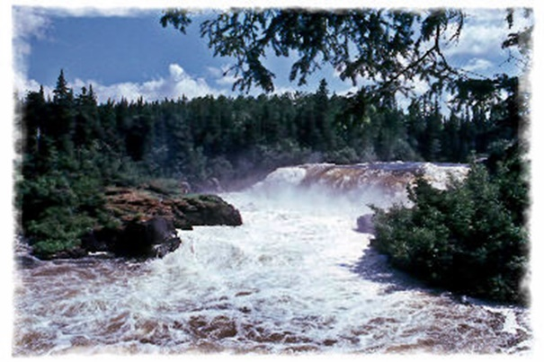

Are you looking for a challenging opportunity in an **Amazing Community** that needs Jesus?

Are you looking for an **opportunity to grow**?

This is not for the Faint of Heart!

We are The Hub of the North!

**Thompson**, population 13,000+ located in beautiful, scenic northern **Manitoba.**

We are a multi-cultural congregation with established ministries in a beautiful functional facility. We have unlimited opportunities for Outreach and a fabulous Board to work with.

    Elementary Schools, High School, University College of The North, a Medical Clinic, Hospital, unlimited outdoor activities (fishing, boating, kayaking, snowmobiling, skiing, Millennium Trail, etc.), and lots of community activities for children and adults.

If the Lord is speaking to your heart and you want more information, please contact:

Andrew Porterfield, District Superintendent

[andrew@paoc.net](mailto:andrew@paoc.net?subject=Thompson)

