Christ Victorious Church

**4605, rue Mackenzie, Montréal, Québec H3W 1B2 (514) 731-8630**

*But thanks be to God! He gives us the victory through our Lord Jesus Christ. I Cor.15:57*

## Church Profile

## Christ Victorious Church is an autonomous PAOC congregation located in the Cote-des-Neiges area of Montreal. It is multigenerational and multiracial. The church is mainly Filipino, but it also has people with European, Caribbean and African origins. The services are in English, but Filipino languages are used in some Sunday School classes. A significant number of the Filipino youth were born in Canada and relate more to Canadian culture than to the Philippines. Its website is cvcmontreal.com and the YouTube channel is Christ Victorious Church Montreal.

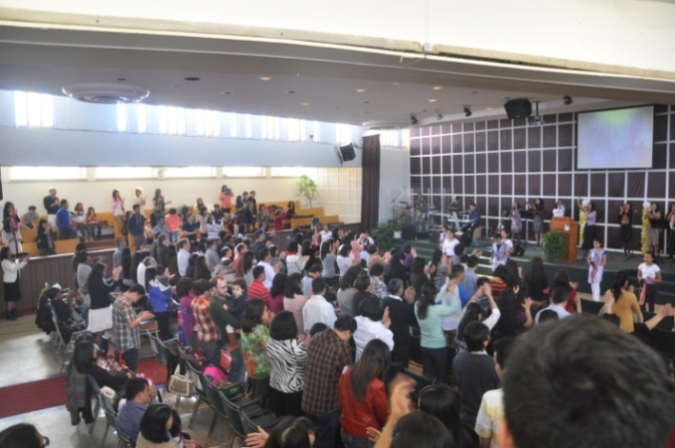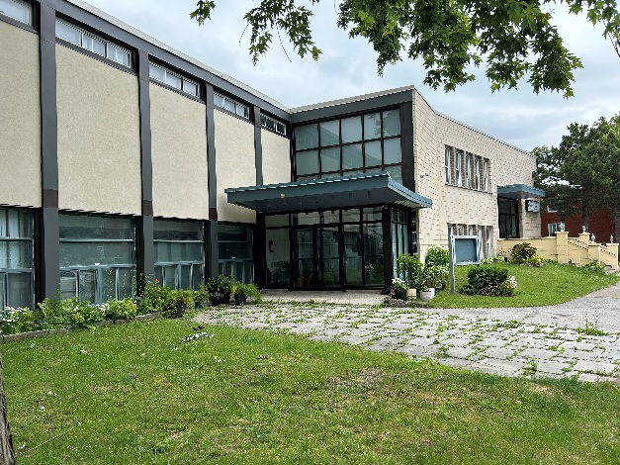

The Notre-Dame des Neiges / Cote-des-NeigesBorough is the most populous borough in Montreal. The Cote-des-Neiges part is home to many immigrants from the Philippines, Vietnam, South Asia, and the Caribbean. There is also a substantial Jewish population. It is one of the lower income areas of Montreal. There are 12 elementary schools: one English and 11 French since immigrant children are forced to attend French schools by law.

**History**

CVC has its origins as the Filipino Fellowship at Evangel Pentecostal Church in downtown Montreal. The Church was commissioned by Evangel in November 1997 to be located in the Cote-des-Neiges district of Montreal. 19 members of Evangel formed the founding members of the new church. The pastors since the founding have been Pastor Victoria Asprec and Pastor Bejserlino Serra.

The church was initially a developing assembly under the umbrella of the Eastern Ontario and Quebec District and later the Quebec District. It incorporated in 2006 under the Quebec Religious Corporations Act with a seven member board – the senior pastor and six elected members. The six elected board members serve for three years with two retiring and two being elected each year.

The church met in leased premises on the second floor at 6484 Victoria Avenue until 2009 when God provided the church with its own building, a former synagogue, at 4605 Mackenzie Street. It was bought for $1,526,000, financed by $526,000 in cash and a $1,000,000 mortgage from the PAOC Pension Fund. The mortgage balance is currently about $150,000. The church has made about $1,000,000 in improvements and renovations.

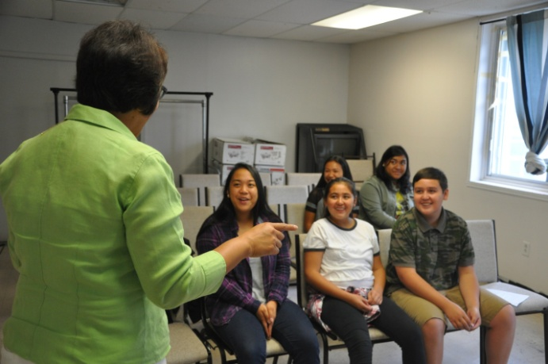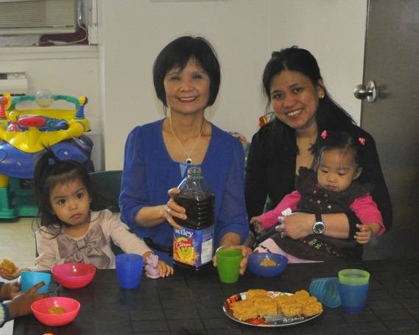

The sanctuary has about 300 seats but has a maximum capacity of about 400. The overall floor area of the building is about 22,000 square feet and includes many rooms, a cafeteria and a small kitchen. A section of the basement with its own entrance is leased to a Spanish congregation. The church has a yard with basketball and volleyball courts, and room for some parking.

Average annual income is around $405,000: $350,000 in general giving, $32,000 designated giving including missions, and $23,000 rental income. Aside from the pastor, all other responsibilities are fulfilled by volunteers. The mortgage is being paid at an accelerated rate of $6,000 per month and will be fully paid off by November 2026.

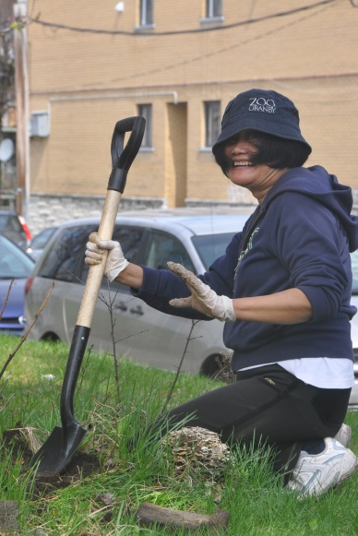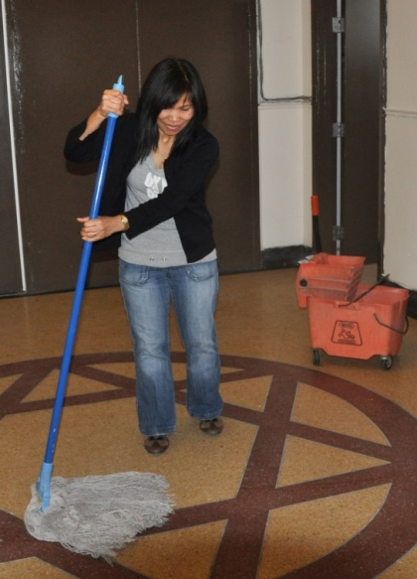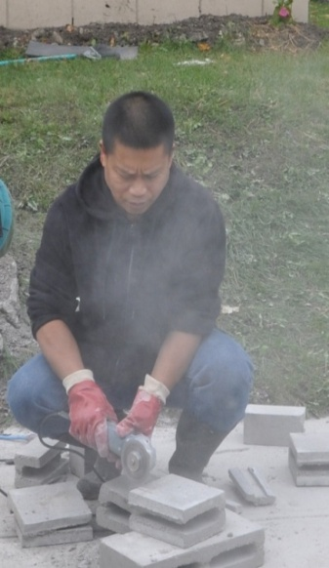

**Participation Statistics**

Members 188 active, voting

Average Sunday a.m. attendance 215 including children

Average Sunday p.m. attendance 30 including children

Wednesday evening service 15

Friday evening youth service 25

Sunday School 60 adults + 35 children

Home Bible Cells 5 cells with a total attendance of 60

Children’s Church (during a.m. service) 35 children ages 4 to 11

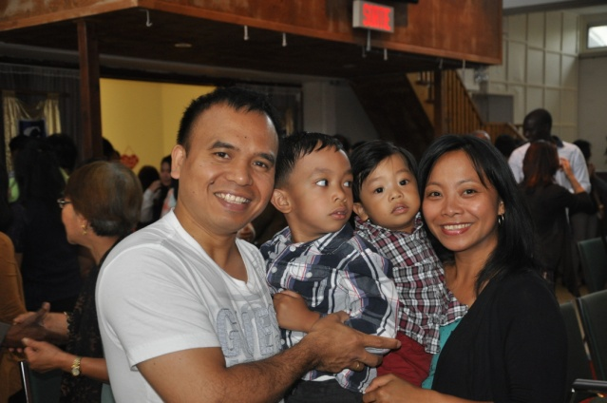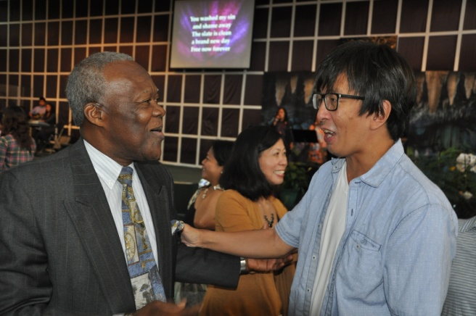

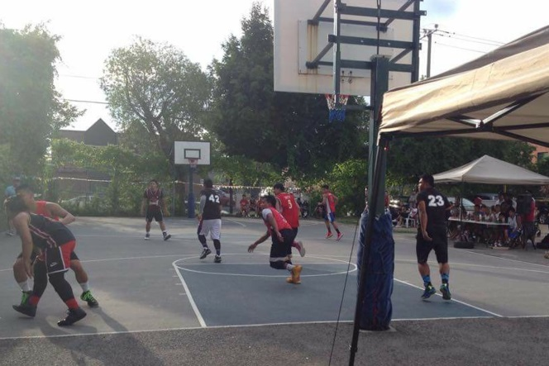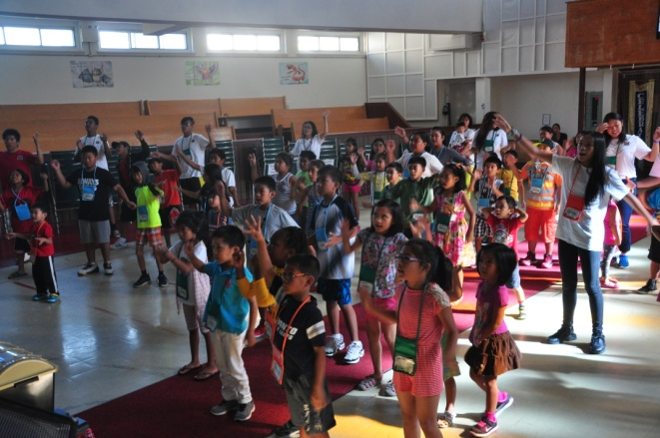

**Other Ministries**

Worship teams (musicians, singers, interpretive dance)

Nursery (during Sunday School and Sunday A.M. service)

Women’s Ministry

Men’s Ministry (currently not operating)

Young Adults

Couples Events

Welcoming Ministry, Ushering

Helping Hands Ministry, Outreach and Benevolence

Vacation Bible School (not held since the pandemic)

Special Fellowship Outings (e.g. Waterpark, Cabane a Sucre, Granby Zoo, Apple Picking)

Special Church Events (Baptism, Easter, Mother’s Day, Fathers’ Day, Christmas)

Intercessory Prayer (Monday to Friday evenings, except Wednesday)

21 Day Fast in January

Baptismal services at a beach or pool

Nursing Home Outreach

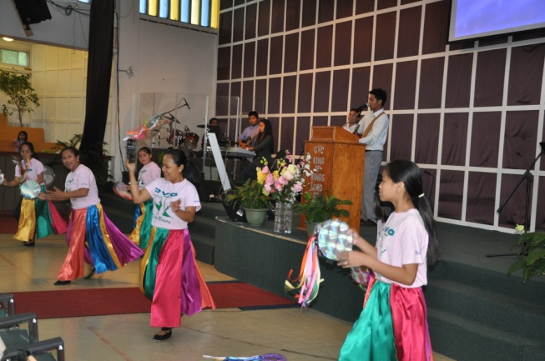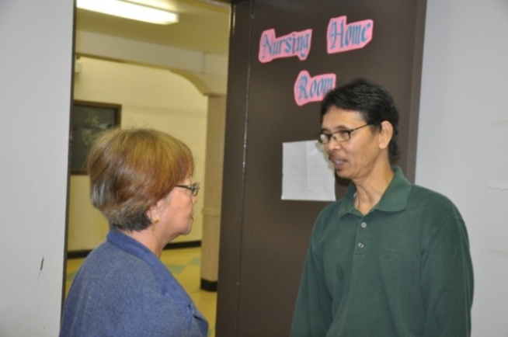

**Strengths**

Lively worship

Willing and responsible volunteers

Active home Bible cells

Financially responsible

Active and committed core

Spacious facilities

**Challenges**

Outreach to entire local community

Stronger missions perspective

Engaging youth and strengthening programs

Strengthening children’s programs

Building Sunday school attendance

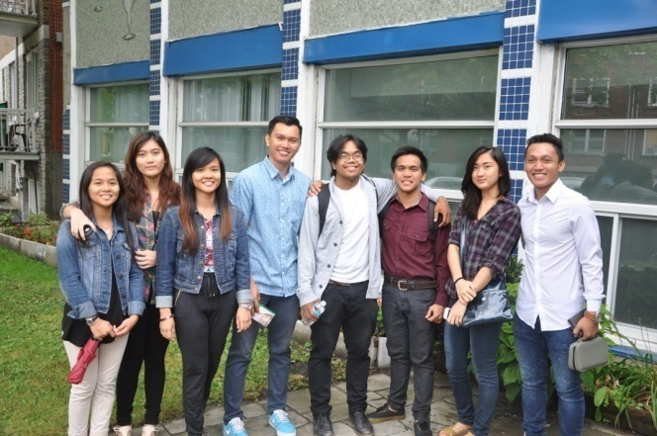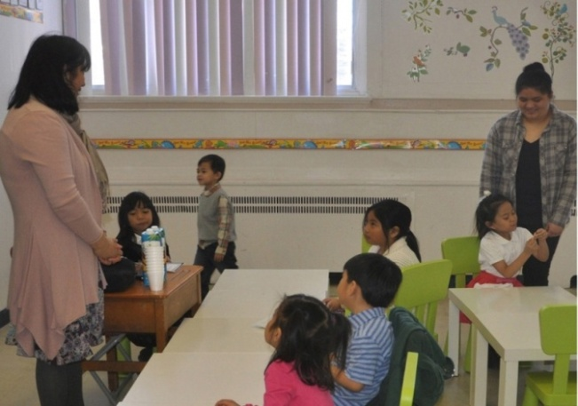

**Candidate**

Effective communicator able to rightly divide the Word of God

Able to relate to various cultures and age groups

Sensitive to the leading of the Holy Spirit

Caring, people-oriented

Heart for outreach and missions

Able to recognize and develop gifts and talents

Able to develop a clear vision and direction

Encourage Christian growth

Lead by personal example and integrity

Demonstrate support for all ministries