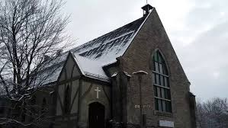 **The Bible Way Pentecostal Church Profile 2024**

# Bible Way Pentecostal Church Profile CHURCH PROFILE

## Introduction

Bible Way Pentecostal Church is a self-sufficient autonomous English-speaking congregation located in the borough of Sud-Ouest in the City of Montreal. The population of Sud-Ouest is approximately 71,546 (2011), but Bible Way Pentecostal Church draws members from all areas of the city. The church is affiliated with and active in association with the Pentecostal Assemblies of Canada.

## Mission Statement

The ministry's stated mission is to "lead people into a growing relationship with Jesus Christ and to strengthen the local church."

## Qualities Needed in a Pastor

**• Holy Ghost filled**

**• Be led, directed & sensitive to the Holy Spirit**

**• Love to pray**

**• Integrity and Humility**

**• Godly Wisdom & Character**

**• A Visionary Leader**

**• People skills**

**• Strong Leadership skills**

**• Team Oriented**

**• Skilled in the Word**

## Church Staff

**• Joslyn Bradshaw - Secretary**

## Church Ministries

**• Senior Choir**

**• Prayer Team**

**• Orchestra and Worship Teams**

**• Christmas and Easter Programs**

## Annual Giving

## $164,415 Total

General Offerings: $143,344

Building Fund: $6,609

Children's Church: $75

Ministries: $1,010

Food Bank: $6,580

## Strengths

**• Designated a Heritage Building by the City of Montreal since 4 years ago.**

**• We love to worship.**

**• We love to pray.**

**• Not a strength (noted next to some statements)**

## Weaknesses

**• Poor Sunday School attendance.**

**• Needs to be built, strengthened, and encouraged.**

**• No youth involvement.**

**• Many children and youth are not attending church at the current time.**

## History

In the late 60s and early 70s, there was a huge migration of people from the West Indies to Montreal. Quebec at that time was not familiar with their cultural distinctiveness.  
  
In the summer of 1966, presiding Pastor Rev. Fred Parley at Evangel Pentecostal Church made an inspiring announcement that the Rev. St. Clair Knights from Trinidad was coming to start a work in the city.  
  
The first service was held on October 26, 1966, at the Westmount YMCA on Sherbrook Street. At this service, the Holy Spirit moved in a mighty way, and it was during one of these services that the Bible Way Pentecostal Church became an official name.  
  
Within a short while, Bro. Winifield Hope from Barbados joined Rev. St. Clair Knights and immersed himself in the work. He became an Assistant Pastor and was very active in every aspect of the church. In less than two years, the church membership increased greatly, thus requiring more space. The church was relocated to United Church at Wolf Street. God blessed the work tremendously, and soon departments and workgroups were put in place.  
  
As the church grew, the need for more space arose. The Lord led us to our present address on Coursol Street, where we bought the building from the Anglican Church of Canada. It was dedicated to the Glory of the Lord as the Bible Way Pentecostal Church.  
  
As the membership continued to grow spiritually and numerically over the years, a new work started on the South Shore, which is now officially known as the Brossard Evangelistic Centre.  
  
Bible Way is a “Church for all Nations.” Since the 60s and 70s era, the church has moved away from the distinctive West Indian thrust and now focuses on multicultural outreach within Montreal. However, the church has not recovered well from the COVID situation, and the congregation has dropped somewhat.  
  
Recent renovations have been undertaken to improve the church facilities.

## Ministers Who Have Served the Congregation

**• Rev. St. Clair Knights (1966 – June 1985)**

**• Pastor William Massey (Sept. 1985 – March 1989)**

**• Evangelist Alex Lappos (interim) (April 1989 – May 1990)**

**• Pastor Peter Bazillion (interim) (Short period)**

**• Rev. Horace Thompson (Dec. 1991 – Oct. 1995)**

**• Rev. Marie Miller (February 1996 – January 1998)**

**• Rev. Conrad Santa (1998 – April 2001)**

**• Pastor Thomas N. Fergus (2001 – April 2016)**

**• Pastor Michael Dukefe (2017 – June 2023)**

**• Pastor Jerry Thompson (Short period, 2023)**

** Reverend Daniel Nurse (Current interim Pastor)

## Congregational Makeup

Figures are approximate based on statistics as of December 2023:  
• BPC has a membership of 60 adults (updated from 93 adults, with an average attendance of 50)  
• 50 Adherents  
• 10 Youths  
• 20 Kids on Sunday  
• Average Sunday AM attendance: 100 (including children)

## Contact Information

Bible-Way Pentecostal Church  
2390 Coursol Street  
Montreal, Quebec H3J 1C7  
Phone #: (514) 932-8225  
Fax #: (514) 932-8254  
Email: bibleway@bellnet.ca

## Board Members

**• Margaret Small**

**• Joyce Gray**

**• Pierre Dumay**

**• Dana Collins**

**• Albert Anderson**

## Financial Information

General Offerings: $143,344

Building Fund: $6,609

Ministries: $1,010

Children's Church: $75

Food Bank: $6,580

Hospitality: $789

Annual Giving (2023): $164,415 Total

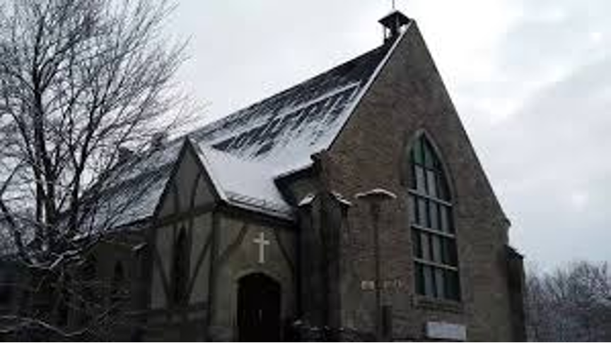

**Bible Way Pentecostal Church 2024**

**Church Profile**