Want more information?

Our Pension Fund team would be happy to answer questions from you or any Church Board that is looking to enhance an employee benefit package through this excellent savings vehicle.

If you would like someone to be available to answer pension questions at a future Board meeting, an informal “Zoom” chat can also be arranged.

Take advantage of the DB plan.
Contact us for more information today!

Contact
P: 905-542-7400 or Toll Free: 1-866-877-8481
Email: pensioninfo@paoc.org
Further information about the DB pension plan is available on our website:
www.paocpension.org
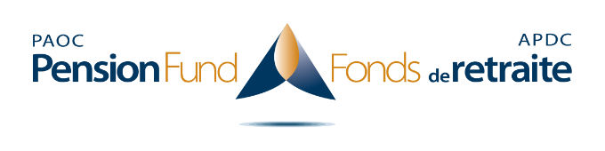
2450 Milltower Court, Mississauga, ON L5N 5Z6
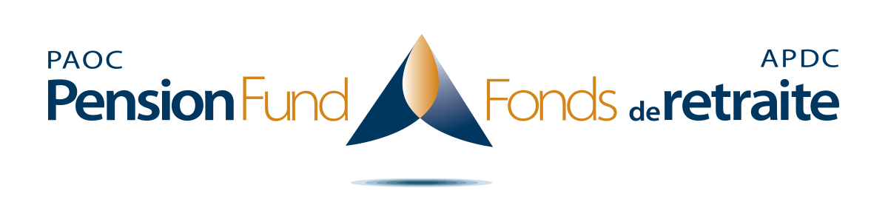

A Defined Benefit PLAN
with PURPOSE

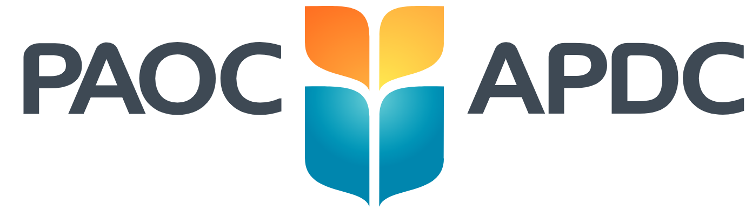
The best time to save for retirement is now!

It takes careful planning to prepare for those retirement years ahead. Why not consider adding participation in PAOC’s Defined Benefit (DB) pension plan to your retirement savings portfolio?

The DB plan was first established at the 1938 General Conference. It was specifically created and designed to help those serving in PAOC ministry, both in Canada and worldwide, to receive stable retirement income.

Monthly contributions matched by your employer, even at the minimum allowable percentage, can greatly enhance what you may receive from government sources such as CPP and OAS.

Who qualifies for membership?

- Credential holders with full-time employment in a PAOC local assembly or affiliated ministry, as well as those who serve part-time under certain conditions.

- Non-credentialed staff in the same categories, where they qualify for church membership according to the Local Church Constitution.

Key benefits

- Your contribution is considered a tax deduction and lowers your taxable income now.

- Your eventual pension benefit grows with each contribution received. The expected annual pension is equivalent to 10% of total contributions received over the years.

- The pension received is for life, with an opportunity to make provision for a lifetime spousal pension at the time of retirement should you predecease your spouse.

- Income is stable throughout retirement, unaffected by market fluctuations.

- Includes ancillary benefits (disability pension if needed, and early or postponed retirement options).

- As a multi-employer pension plan, should you change ministry positions in the future, you can continue contributing with any other PAOC affiliated assembly or ministry with whom we have a Participating Employer Agreement (PEA).

- Participation supports PAOC mission through investments in church/ministry mortgages, which account for at least 40% of the DB plan investment portfolio, depending on demand and other strategic criteria at the time.

- Each Spring, you will receive an Annual Benefit Statement, showing your contributions and projected annual pension benefit.

- Members can access the pension portal, which provides valuable information, including use of the pension calculator and the ability to track their contribution history. To register: http://register.paoc.org.
How does an employer participate?

We may already have a PEA on file from your employer. If so, we simply need to receive a completed Pension Fund Application, which can be downloaded from our website or obtained by contacting our office. Your employer then deducts the agreed-upon percentage from your pay within the required parameters (see chart below), matches it and remits the amount to this office within 30 days of the deduction from pay.

If your employer does not have a PEA with us, it can easily be obtained from our office.

Contribution Rates*
 | Minimum Member | Minimum Employer | Minimum Combined | Maximum Member | Maximum Employer | Maximum Combined
Years 1 & 2 | 2.5% | 2.5% | 5% | 10% | 10% | 20%
Years 3 & 4 | 4% | 4% | 8% | 10% | 10% | 20%
Years 5 & after | 5% | 5% | 10% | 10% | 10% | 20%
*Contributions are based on gross remuneration and clergy housing benefit, where
applicable. While all employee contributions must be matched by an employer, it is
permissible for an employer to contribute more than an employee.

***
It’s more important than ever to choose a
solid retirement plan!

