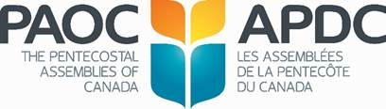

**LEVELS OF SPONSORSHIP**

**PAOC General Conference 2024**

**Benefits *of your* Sponsorship**

**PLATINUM GOLD SILVER**

**$10,000 $5,000 $1,500**

**____________________________________________________________________________________________**

**Listed on the PAOC website as an “Official Sponsor”**

**of the 2024 General Conference.**

**Ad in the digital conference magazine**

Platinum: *Full Page* Gold: *2/3 Page Silver: 1/2 Page*

**Post Conference *Testimony* & *Enrich* Ad**

All the conference sponsors will be honoured

**Acknowledgement as a sponsor on our General** **Conference whova App**

All the conference sponsors will be honoured

**Lunch Sponsor**

Platinum sponsors who assist with the Tuesday’s lunch cost receives the opportunity for a 2-3 minute video presentation

**Listed on delegate badges as “Premier Sponsor”**

Platinum sponsors only

**Assigned one Premium Exhibitor Space**

This Space is located in a prime location

**Hotel Room for four (4) night’s stay during conference**

**Coffee Break Sponsor**

Sponsors who cover the cost of a conference coffee break receives the opportunity for a 2 minute video presentation

**Assigned one High Profile Exhibitor Space**

This Space is located in a priority location

**Assigned one Standard Exhibitor Space**

This Space is located in a secondary location