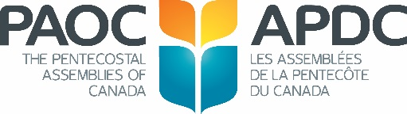
Missions Giving Remittance Form
Church ID:
Church Name:
City, Prov. |  |  |  |  |  |  |  |  | For Office Use Only
Primary Contact: ___________________ | ___________________________
Contact Email: | ___________________________
 |  |  |  |  |  |  |  |  | Total
Save time, save money – Give via our Online Remittance Option
For more details, please email our Receipting Dept. at donations@paoc.org
Details |  | Amount |  |  |  | Details |  |  |  |  | Amount
Global Worker Support |  |  |  |  |  | Mission Canada Worker Support
Name: |  |  |  |  |  | Name:
Name: |  |  |  |  |  | Name:
Name: |  |  |  |  |  | Name:
Name: |  |  |  |  |  | Name:
Name: |  |  |  |  |  | Mission Canada
Name: |  |  |  |  |  | Mission Canada (Vision & Initiatives)
Name: |  |  |  |  |  | Refugee Resettlement in Canada
Name: |  |  |  |  |  | Cultural Language Ministries
Name: |  |  |  |  |  | Next Gen Children Youth Campus
Name: |  |  |  |  |  | Quebec and Francophone Canada
Name: |  |  |  |  |  | Aboriginal Ministries
Name: |  |  |  |  |  | Urban Centres
Missions Global
MG NOW (Where Most Needed) |  |  |  |  |  | Priority One Offering
MG Project: |  |  |  |  |  | Missions Global/Mission Canada
MG Project: |  |  |  |  |  | Missions And Kids (MAK/SAM)
MG Project: |  |  |  |  |  | General Giving:
Living Memorial |  |  |  |  |  | Specify:
In Memory of: |  |  |  |  |  | ZOE Projects
 |  |  |  |  |  | General Giving:
 |  |  |  |  |  | Specify:
Please make cheque payable to “The Pentecostal Assemblies of Canada” |  |  |  |  |  |  |  | Total
Additional Notes: | _______________________________________________________
ERDO Donations
Please make separate cheque payable to ERDO
Description |  | Amount |  |  | Description |  |  |  |  |  | Amount
ChildCARE Plus – Area of Greatest Need |  |  |  |  | ERDO – Area of Greatest Need
ChildCARE Plus – Sponsor #:  Child’s #: |  |  |  |  | ERDO Project – Specify:
2450 Milltower Court, Mississauga, Ontario L5N 5Z6
tel: 905.542.7400 fax: 905.542.7313
web: www.paoc.org email: donations@paoc.org
Revised: December 2015
THE PENTECOSTAL ASSEMBLIES OF CANADA

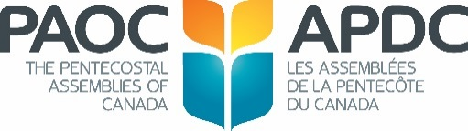

MISSIONS GLOBAL AND MISSION CANADA INFORMATION
- Please use this form for all PAOC missions’ contributions.
- Please remit one cheque for all MISSIONS GIVING.
- For donations to a specific priority in Canada ie: Aboriginal, Campus, etc., please contact the Mission Canada Team.
- Donations for a field, project or Global Worker will be applied to the budget unless otherwise specified. For assistance with any designation codes, please contact the Global Missions Team.
- Funds are generally forwarded within 3-5 weeks of receipt.
- Income Tax receipts are issued at year-end.

For more information on mission or shared funding visit us at www.paoc.org
Designated Giving:
“If a project has been fully subscribed, The Pentecostal Assemblies of Canada reserves the right to
re-direct the funds to where most needed.”

Remittance forms can be downloaded from the PAOC Website – click on Fellowship Services >
Church Resources > Remittance Forms

--------------------------------------------------------------------------------------------------------------------------------------------------

ERDO
For all ERDO Donations, please remit separate cheque payable to: ERDO.

For more information on ERDO please visit us at www.erdo.ca or email info@erdo.ca

Designated Giving:
“If a project has been fully subscribed, ERDO reserves the right to
re-direct the funds to where most needed.”

