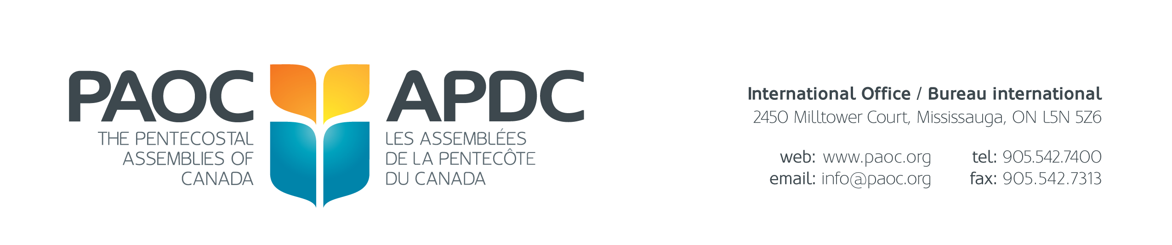
Appointment of a Lay Delegate
General Conference of the General Conference 2024

As per the General Constitution and By-Laws in Article 8.1.4 there is opportunity for local assemblies to appoint lay delegates as stated below:

Article 8.1.4 Duly appointed lay delegates from an affiliated assembly.

Each local assembly affiliated with The Pentecostal Assemblies of Canada is authorized to appoint and send one (1) lay delegate to each General Conference. Those churches with a membership of 200 or more shall be entitled to two (2) delegates. For each additional 100 active official members recorded on the membership roster of the local assembly, the church may send one (1) additional delegate. These delegates shall be Spirit-filled members in good standing with the assembly.

Lay delegates shall not be credential holders or the spouses of voting credential holders.

Lay delegates must present a letter of authorization from the secretary of the church board to the conference registrar.

To the General Secretary Treasurer:
In accordance with Article 8.1.4, this is to certify that the following member of the local assembly is duly appointed as lay delegate to represent this local assembly at the 2024 General Conference in Niagara Falls, ON. (The signature of the Secretary of the Board on this form, or on a separately dated letter of appointment presented at the time of registration, clearly indicating the name of the affiliated assembly and the name of the lay delegate, will constitute authorization by the local assembly to register the named person as a lay delegate.)

Name of Appointed member of this Local Assembly
*Please register the lay delegate showing their personal information included on this form.

Name of Affiliated Assembly

Mailing Address Telephone

Number of Official Members (as reported on the 2022 ACLR Survey)

Signature of Secretary of the Board Date

Please send the completed form to gc2024@paoc.org. The link to register your lay delegate(s) for the conference is: https:// https://paoc.org/events/general-conference-2024/registration. If you experience any difficulty with online registration, please call Sharon Thomson, conference registrar at 905-542-7400.

